The goal of this document is to record how to do period tracing in a 2-parameter bifurcation plot using Xpp-Auto.

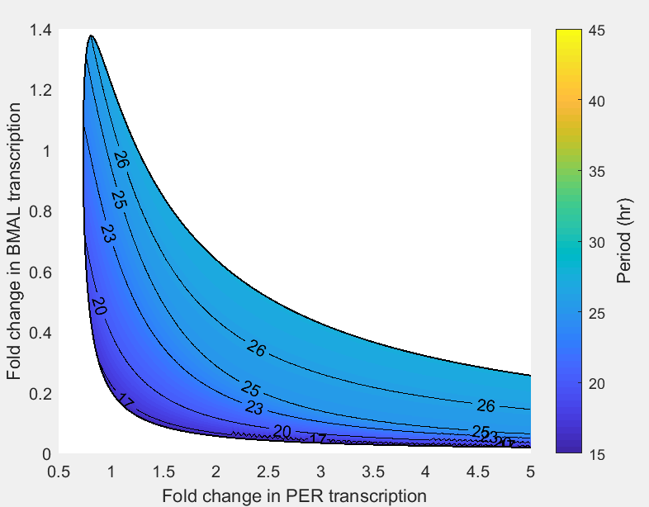

Fig5. SNF 2M8 period tracing heat map.

Step1: Find the boundary curve for the oscillatory region

Step2: Period tracing such that contour line can be drawn (focus of this document)

Step3: Load data in Matlab and interpolate to plot the heat map.

To accomplish Step 2, the task is broken into several tasks below.

2.1 1 parameter bifurcation for grabbing the Hopf bifurcation point

2.2 “Usr Period” to save data points of user specified value on the branch

2.3 Set axes to “Period” and hit “Run” (“2 par” crashes for some reason)

2.4 Grab the point with certain period and “Run” -> “Fixed Period”

2.5 Save all the data by “File”-> ”All info”, the 4th-6th column record the 1st ,2nd parameter value and the 3rd column records the period value.

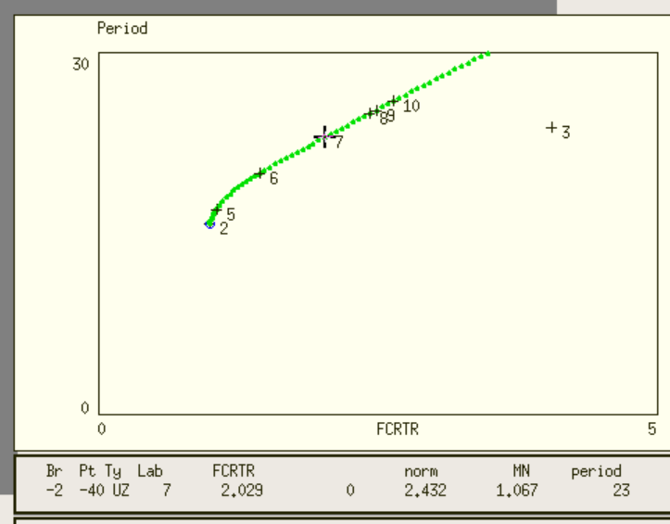

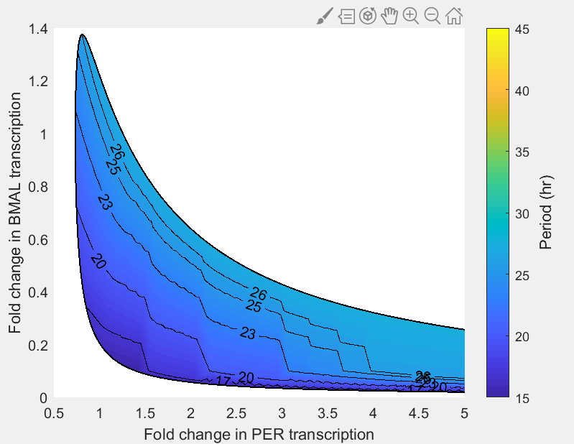

Issue: unsmooth contour curves probably due to the lack of data points for Matlab interpolation

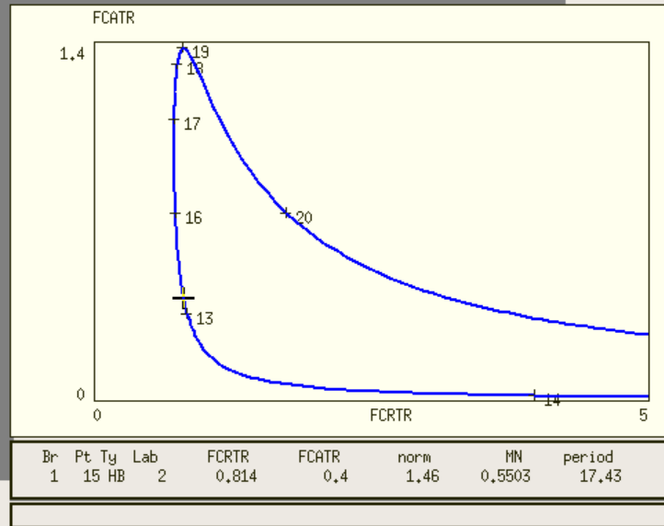

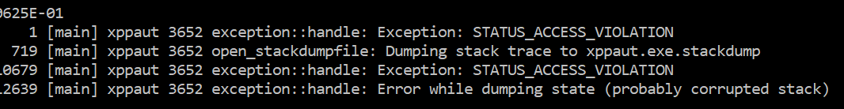

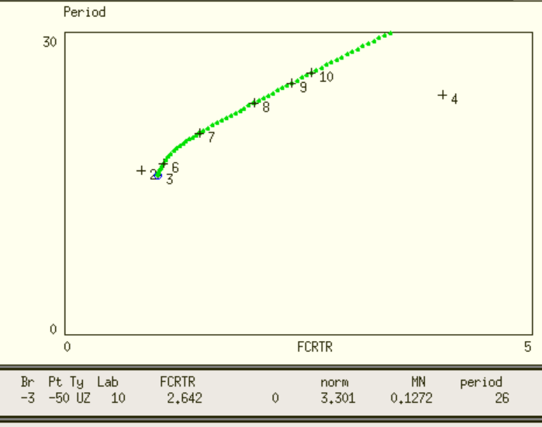

grab a point and run “fixed period” with both negative and positive step size

